Hai’s Beta3 Plan

Hai’s Beta3 Plan 1
1 Time Table 2
2 Many To Many 3
2.1 Concepts clarification 3
2.1.1 Join operator association rules 3
2.1.2 Dimty Extension & Pseudo Table 3
2.2 Design & Implementation 4
2.2.1 Optimize Join Tree on Fact Tables 4
2.2.2 Conversion 5
2.2.3 Populate PseudoTable 5
3 Join with Partial Relationship 6
3.1 Current Join Algorithm 6
3.1.1 MakeJoins (iAttr, iFromUnit) 6
3.1.2 MakeJoinsUp (iAttr, iFromUnit) 6
3.1.3 MakeJoinsM2M (iAttr, iFromUnit) 6
3.2 Improvement Proposal 7
3.2.1 MakeJoinsUp 8
3.2.2 MakeJoinsM2M 8
3.2.3 MakeJoinsPartial 8
3.2.4 JoinTablesWithPartial(iFromUnits) 9
3.2.5 DFCFrom::JoinLkups() 9

Time Table

 |  | Design/Implementation Time | Order
M2M | Concepts / Logic | 2 day | 1
M2M | Optimization | 2 days | 2
M2M | DimtyExt Handling | 2 days | 4
M2M | Testing / Cleanup | 2 day | 3, 5
M2M |  | 8 days
Join with Quality | MakeJoinsUp | 0.5 day | 6
Join with Quality | MakeJoinsM2M | 1 day | 3
Join with Quality | MakeJoinsPartial | 2days | 7
Join with Quality | Testing / Cleanup | 2day | 8
Join with Quality |  | 5.5 days

Many To Many

Concepts clarification

Join operator association rules
Tables: A, B, C
Operators:  (inner join), ⊕ (full outer join), ⊗ (cross join)
Identities
(A  B)  (A  C) = (A  B)  C
(A ⊕ B)  (A ⊕ C) = (A ^{LOJ} B) ^{LOJ} C
(A ⊗ B)  (A ⊗ C) = (A ⊗ B) ⊗ C ^{or} (A ⊗ B)  C (depending on if key_{BC} = ∅)
(A  B) ⊕ (A  C) =
(A  B) ⊗ (A  C) =
Proof of the first identity:
LHS: For each row element of the join key 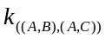, it can be decomposed as 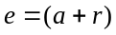, with 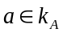 and 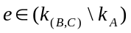. The multiplicity of the row element is 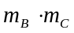 where
- 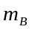 is the multiplicity of in 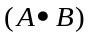, or the number of rows in B containing as well as the 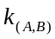 part of
- 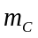 is the multiplicity of in 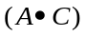, or the number of rows in C containing as well as the 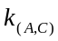 part of
RHS: As shown above, the multiplicity of in is . Since the join key of the final join 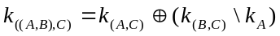 is a subset of the join key , the multiplicity of in the final join is further multiplied by , which is the number of rows in C containing as well as the part of .
○

FT
R1
⊗
FT
R2
•
⊕

Dimty Extension & Pseudo Table
ExtTable is created during conversion time. PseudoTable is created during EngineAnalytical pass.
- ExtTable is one-to-one mapped to DimtyExt in COM. Each M2M corresponds to a DimtyExtUnit.
- PseudoTable is created in 1) DFCDimtyExt::MatchExtension() if the ExtTable with the extension covers the analysis key for FindBBT, and in 2) DFCFactSet::FindBestTable() if first FindBestTable failed and we do a cross-join extension.
We will define a new relationship between A3 and B1 at Schema Loading time. The new Rel should record the join attributes as M2M attributes A1 and B1, plus the child on the fact table A3, and the relationship table A1_B1. This way, the join path can be built in ExpandPDTable. However, it will require MakeJoinsUpWithM2M as we raise the fact level from A3 to B1.

A1
A2
A3
B1

In situation like B ^{R1} A ^{R2} C, where fact level is A and dimensionality is (B, C). Do we want to generate PDTable as on the left or on the right?
FT
R1
FT
R2
FT
R1
R2

This choice can be made at one of the following stages:
- At conversion time, for each M2M, do we create a new ExtTable or a new DimtyExtUnit within a ExtTable? If we choose the first option, then it may be problematic – FindBBT at (B, C) level may fail.
- At ExpandPDTable, we can decide what type of tree we want to construct.
- Important: BaseTableJoin may also produce type of join tree on the left. So perform opimization at the end of BaseTableJoin?
PDTable Tree Optimization
For the first case, we can optimize the PDTable tree at later stage. In case on all inner joins, the tree on the left can be optimized to the tree on the right. But what about when cross and outer joins are involved?
- Handle cross join and outer join in a new function DFCFrom::OptimizePDTTree
- Handle cross join and outer join in existing function DFCFrom::ConstructTree
Both called at the end of ExpandPDTable.

Design & Implementation

Optimize Join Tree on Fact Tables
Where do we do optimization? Or what is the scope of optimization?
- Right after FindBBT?
- At the end of ExpandPDTable? Only within each PDTable.
- After FlattenTree and lookup table optimization? For the entire join tree of DFCFrom.
Algorithm
- Add DFCFrom::OptimizeTreeOnBaseTables
- Add DFCFromUnit*::FindFirstReplaceableBaseTable()
- Add DFCFromUnit*::OptimizeOnBaseTablesPerRefNode()
Rules
  - To be determined
  - RefNode is a base child of an Outer Join (i.e., left child of a Left/Full Outer Join node)
  - If an Outer-Join node, optimize left and right subtrees independently
  - If a Cross-Join node,
- Add DFCFromUnitLeaf::CanReplaceBaseTable(iRefTable) If iRefTable covers this→mTable, which means
  - Columns(iRefTable) ⊃ Columns(this→mTable)
  - Key(iRefTable) ≥ Key(this->mTable)
- Add mFactTableReplacement flag to DFCFromUnitLeaf

Conversion
- For each M2M, construct Dimty Extensions for all children of each of the M2M attributes.
- Set M2M.mExtnType = ROLAP_REL_M2M (create new ExtnType)
- Set M2M.mAttrs = Schema→FindAttr(M2M.mSource) ∪ {current child}

Populate PseudoTable
DFCRel::FindTable(iPDTable, iAttrGroup)
switch mExtnType
……
case ROLAP_REL_M2M :
iPDTable→InsertJoinTable(mUnion.mTable)
iPDTable→InsertJoinAttrVec(mAttrs)
……

DFCFrom::ExpandPDTable()
LLHSRoot = new DFCFromUnitLeaf(FactTable)
for each JoinTable
lRHSRoot = new DFCFromUnitLeaf(JoinTable)
for each JoinAttr
lRHSRoot = MakeJoins(JoinAttr, lRHSRoot)
for each JoinAttr
lTmpRoot = MakeJoins(joinAttr, lLHSRoot)
if (lTmpRoot)
lLHSRoot = lTmpRoot
else
lLHSRoot = MakeJoinsUpWithM2M(JoinAttr, lLHSRoot)
lLHSRoot = ConstructTree(lLHSRoot, lRHSRoot)
oFromUnit = lLHSRoot

Join with Partial Relationship

Current Join Algorithm

MakeJoins (iAttr, iFromUnit)
Targeted Attrs
Type A path
Starting from iAttr, find a path in the data model, such that the targeted attrs, which can be
- either the terminal of the path (if no partial-relationship edges on the path), or
- or a node on each partial-relationship branch from the path (if any partial-relationship edges on the path)
are covered by iFromUnit
iAttr

MakeJoinsUp (iAttr, iFromUnit)
iAttr
Targeted Attr

iFU
JoinTables
Common Ancestor

Starting from iAttr, find a path (with no partial relationships), such that the lookup table of the terminal of the path (targeted attr) can be joined with iFramUnit using JoinTables algorithm

Type B path

JoinTables({iFU, LU})
- Find Common Ancestor, which must have proper refinement in both iFU and LU
- FU1 = MakeJoins(Common Ancestor, iFU)
- FU2 = MakeJoins(Common Ancestor, LU)
- Join FU1 and FU2

MakeJoinsM2M (iAttr, iFromUnit)
Find either type A or B path, but the path may contain M2M edges.
Algorithm:
If iAttr covered by iFromUnit, done, else
- Call MakeJoins on iAttr→M2M, if not found
- Call MakeJoinsUp on iAttr→M2M, if not found
- Call MakeJoinsM2M on iAttr→Children, if not found
- Call MakeJoinsM2M on iAttr→M2M

Improvement Proposal
We insist on the following hierarchy in finding join paths:

Downward Edge
⇓
Complete Partial Downward Edge Set
⇓
Upward Edge
⇓
Complete Partial Upward Edge Set
⇓
M2M Edge
⇓
Partial Downward Edge
⇓
Partial Upward Edge

Combine DownwardJoin() into MakeJoinsUp()

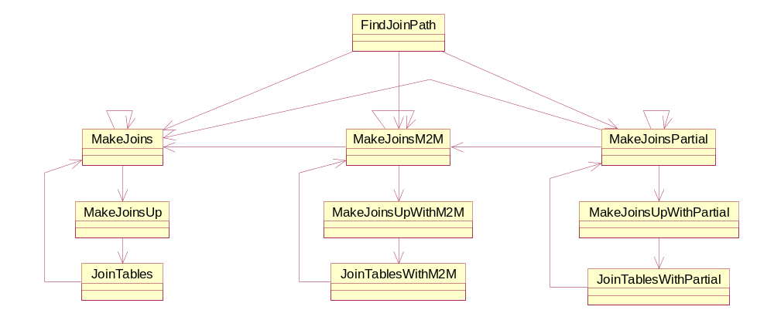

MakeJoinsUp
Also check joint children
lTmpRoot = iFromUnit;
for each child in a joint children group
if (lFU = MakeJoins(child, lTmpRoot))
lTmpRoot = lFU;
lPathAttrs.insert(child);
continue;
if (lFU = MakeJoinsUp(Child, lTmpRoot))
lTmpRoot = lFU;
lPathAttrs.insert(child);
continue;
break;
if reach the end
iFromUnit = lTmpRoot
else
reset lPathAttrs

Targeted Attrs
iFU
JoinTables
LU1
LU2
LU3
Type B path (new)

MakeJoinsM2M
We need to allow M2M to exist on the left part of type B path.
Add MakeJoinsUpWithM2M, which calls DownwardJoinM2M, which calls JoinTablesM2M:
If iAttr covered by iFromUnit, done, else
- Call MakeJoins on iAttr→M2M, if not found
- Call MakeJoinsUpM2M on iAttr→M2M, if not found
- Call MakeJoinsM2M on iAttr→Children, if not found
- Call MakeJoinsM2M on iAttr→M2M

MakeJoinsPartial
Find either type A or B path which may contain incomplete partial relationships, as well as M2Ms,
Add MakeJoinsUpWithPartial, which calls DownwardJoinPartial, which calls JoinTablesPartial, so that left part of type B path can contain incomplete partial relationships, as well as M2Ms:
If iAttr covered by iFromUnit, done, else
- Call MakeJoins on iAttr→PartialChildren, if not found
- Call MakeJoinsUpPartial on iAttr→PartialChildre, if not found
- Call MakeJoinsPartial on iAttr→Children, if not found
- Call MakeJoinsPartial on iAttr→M2M, if not found
- Call MakeJoinsPartial on iAttr→PartialChildren

JoinTablesWithPartial(iFromUnits)
In DFCFrom::JoinTables(), calculate the PartialParentForm for each table on the fly:
initialize vector<bit vector> lPPFVec
for each table t
initialize bit vector lPartialParentForm
for each attribute a ∈ t->mAttrs
lPartialParentForm |= a->GetPartialParentVec()
insert lPartialParentForm into lPPFVec
When finding join attributes for two tables t1 and t2, use
(lPPFVec[1] | t1->GetTotalForm()) & (lPPFVec[2] | t2->GetTotalForm())

Implementation:
//create a bit vector PartialParentForm for each table
// begin
typedef vector<DFCBitVector *, DFCAllocator<DFCBitVector *> > FROM_BVVec;
DFCAllocator<DFCBitVector *> lBVAlloc(mBuffer);
FROM_BVVec * lPPFVec = new(mBuffer) FROM_BVVec(lBVAlloc);

for (i=0; i<lSize; i++) { // for each from unit (table)
DFCBitVector * lPartialParentForm = new(mBuffer) DFCBitVector(iSchema->GetNumAttr(), mBuffer);
DFCAttrGroup & lKey = iFromUnits[i]->GetKey();
DFCAttrGroup::Iterator j = lKey.IteratorBegin();
DFCAttrGroup::Iterator lAGEnd = lKey.IteratorEnd();
for (; j != lAGEnd; j++) { // for each attribute of the table key
DFCAttr * lTempAttr = (*j);
(*lPartialParentForm) |= (*(lTempAttr->GetPartialParentsVect()));
} // for each attribute
lPPFVec->push_back(lPartialParentForm);
} // for each table
// end
……
……
// get both total form and partial parent form for the first table
// begin
DFCBitVector lBVFirst;
lBVFirst.OR(*(iFromUnits[0]->GetTotalForm()), *((*lPPFVec)[0]), mBuffer);
// end
//for each table
//get both total form and partial parent form for the current table
// begin
DFCBitVector lBV;
lBV.OR(*(iFromUnits[i]->GetTotalForm()), *((*lPPFVec)[i]), mBuffer);
// end
lBV &= lBVFirst;

// check if there is anything common in the key
if (!(lBV.Any())) { // there is none so cross join, unless you are told NOT to Xjoin

DFCFrom::JoinLkups()
If JoinTables failed, call JoinTablesWithM2M, and JoinTablesWithPartial

